CORNWALL DEAF COMMUNITY CENTRE
5A East Charles Street
CAMBORNE TR14 8JF
President – Christine Fitzsimmons Chair – Terence Spivey Secretary – Jackie Goldie Vice-Chair (Temp.) & Treasurer – Katherine Thomas

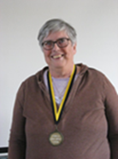
OUR PATRON MESSAGE
Hi, all my friends whom I have really missed catching up with. I am grateful to Deaf Church and the few occasions I have seen some of you. It is such good news that luncheon club is going back to normal, and we can meet together again.
The time of the Covid 19 has been a very hard time for several of us. Nearly all of us have suffered in some way: either ourselves or knowing someone who has been ill or even died and this is not easy to get over so it is good we can meet and be a support to each other.
I am aware that even through the virus there have been people who have still had to have committee meetings, keep the Deaf Centre going, having necessary repairs done etc. and I really want to thank anyone who has helped in any way from the smallest job to the biggest as each part is important to getting things done.
It is good that Deaf Church has also gone back for the past few months, and I know that potato club has met sometimes. We would love more people to come along. I personally am not on Facebook, but I thank Jackie for advertising our events so look out for them. We did have a lovely meeting at the Deaf Centre for our Christmas service and of course we had the luncheon club Christmas dinner. How wonderful was that!
I am also thrilled the newsletter is coming back. Thank you, Katherine, for your hard work on it. Please support it with your news and maybe photos.
If anyone does want to contact me, my email is brenda.clarke1@yahoo.com
I do not know the financial state of the Deaf Centre at the moment but I do know that many charities have suffered badly due to not having collections or events. Money is scarce and prices are increasing every day, but I do encourage you to pay your membership and donate or raise money when you can so that this important meeting place continues.
Love from me and my family - Bill and Maria, Brenda (Patron)
THE CHAIR’S REPORT

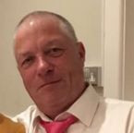
Hi everyone and a Happy New Year. I hope you all had a good Xmas last year.
It had been a long time since we had a newsletter. This is due to coronavirus interrupting our members’ social life at the deaf centre. We had to close the centre for nearly 2 years with no social activities. A lot of members were disappointed and sad, but we had to listen to the government’s law and to keep ourselves safe from coronavirus which had killed a lot of people all over the world. I do hope all the members had 2 vaccines jab plus a booster.
What had been happening in the last 2 years? We were not able to have an AGM in both April 2020 and April 2021 as we were not allowed to have them at that time. We were able to have AGM last November 2021 and it was well attended. We also had the EGM in November 2020, again attended by 30 members with restrictions on social distances. We had a surprise 80th birthday party for Pearl Stoddern. We also had a Xmas dinner at the deaf centre on 11th December 2021 and a Xmas lunch on 15th December 2021. I would like to thank everyone involved on both 11th and 15th December.
When we had the EGM, this was to ask you the members to vote to stay at Charles Street or to move to a new building and with a great majority, the members voted to move. Unfortunately, we have not been able to move to a building as we missed the deadline to receive a grant from EU and this is due to coronavirus, I would like to thank Mark Cuncliffe and Carleen Collins for their hard work. We are still looking for a new building, but this will take time.
At the last AGM, we had a lot to talk about. I would like to congratulate Christine Fitzsimmons on becoming our new President. I would like to welcome Steve Notts as our new fundraiser as Mark Cuncliffe has resigned. Welcome Steve and many thanks for your hard work, Mark. Steve is actively and working hard looking for a new building for us. We have also sadly lost Sarah Wardell due to heavy commitments with her job. Thank you to you too Sarah. I would like to welcome Michael Hooley and Beverley Roberts as our new committee members. I would like to thank all the committee members for all their hard work over the past 2 years. We need more people to join the committee plus need a vice chairperson. Anyone interested in becoming a vice chairperson, please let me know. Our next AGM will be on Saturday 21st May 2022. All members are welcome to attend.
As far as I know, only Helen Spivey had a bad accident in June 2021 breaking her left ankle needing a major operation/reconstruction of her ankle and kept in a cast/boot for 12 weeks. Helen had a lot of up and down with NHS cancelling her operation twice. Helen and I would like to thank Tracey Rail for interpreting. If I have missed anyone out about illness/accident I do apologise but if you do not let me know then I cannot put in newsletter.

Somewhere in this newsletter will be a plan of all activities at the Deaf Centre for 2022 typed by Katherine.

I wish everyone a safe year this year.

Chair Terence Spivey
ACTIVITIES 2022
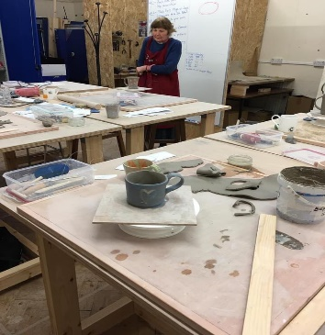
Potato Club: This will start again in February. Rev. Elizabeth Foot received grant for some of the Deaf Church Members to attend Pottery & Glass Making course at the Donald Thomas Centre in Camborne. It is a lovely course, making pots from clay and glazing them. Next week will be making glass ornaments. If successful Elizabeth will apply for more grants so more deaf people can attend.

The Donald Thomas Centre
Chapel Street
Camborne TR14 8EF

Lunch Club: this will start again 9th February and menu is homemade soup, cottage pie & vegetables or roast pork. Trifle, fruit crumble or fruit salad. Please ask Jackie Goldie for your order.

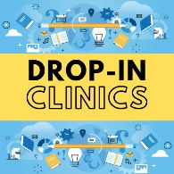
Drop in Clinic: These are really successful. Every Monday at Centre with Interpreter. 10am to 1pm. Help with lots of things, like benefit advice, housing problems. Appointment is best but people can drop in if they like. Contact Jackie Goldie for more information or your Interpreter.

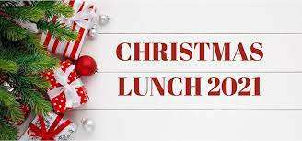
Christmas Lunch: Lovely to see Centre open and full again. Because of Covid maximum of 50 people. Everyone had a lovely time and special thanks to Morrisons & Tesco Supermarkets for providing money towards the food cost, to Bookers (Toby Clemence) for the Turkey, Prawns & Clotted Cream, to Countryman Pub for £50 donation towards costs, Debbie Stokes £10 donation, Lunch Club £60 donation and to all members and shops/businesses who donated raffle prizes. Thanks to all who helped on the day, and before the lunch, Terry Spivey, Clive & Katherine Thomas, Laura Craze, Chanroth Jeffries, Carl & Emily, all helped with peeling vegetables and cleaning the Centre. On the day thanks to Tracey Rail, Linda Hocking, Jannah Stephens & Shan Hampford for serving food and helping with clearing tables. Very big thank you to Terry Spivey for organising the bingo.

Deaf Counselling: Hearing Loss Cornwall received grant to support deaf BSL users in Cornwall to have counselling. The service is free service and will allow deaf people to have online counselling from their homes. If anyone would like more information, please contact their Interpreter, or contact Jackie Goldie. It is a confidential service, and some deaf people are already use this service and have said it is helping them.

Royal Cornwall Show: 9th, 20th and 11th June 2022. Group tickets/Disabled Concession tickets. Contact Jackie Goldie for more information.

Subtitled Films: Cinemas are now open again. If anyone would like to see a film and would like subtitles, please contact Jackie Goldie or Sally Palmer who will try and organise this for you.

CHRISTMAS LUNCH PHOTOS 2021
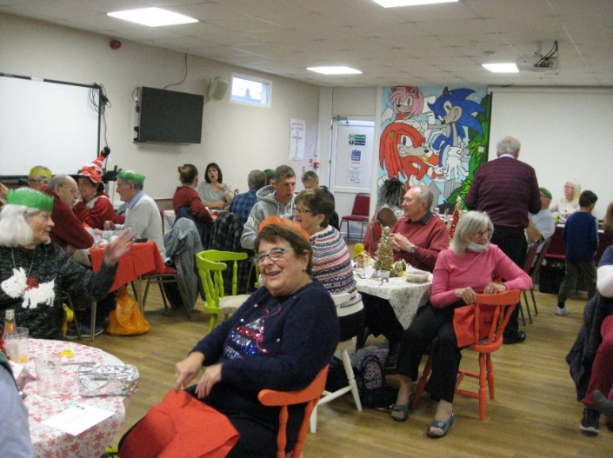
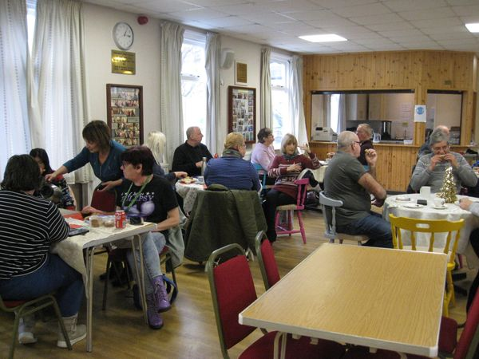

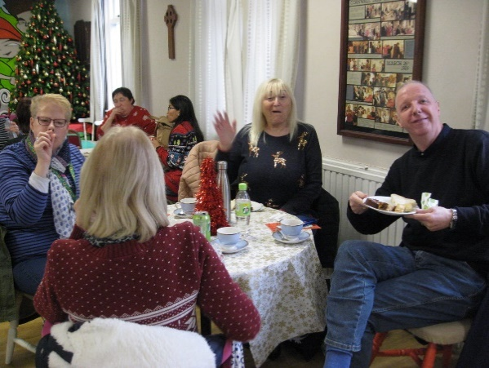
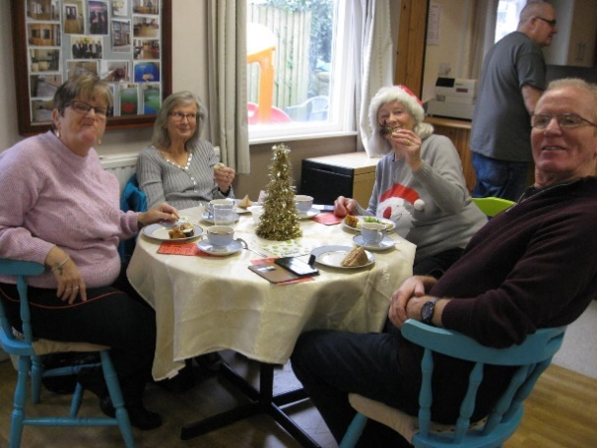

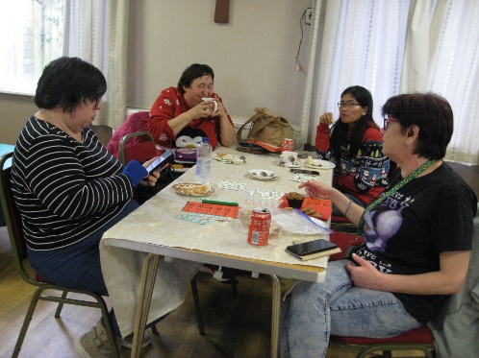
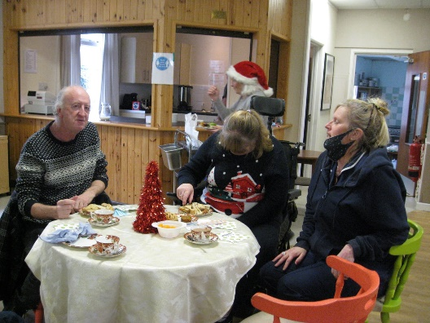

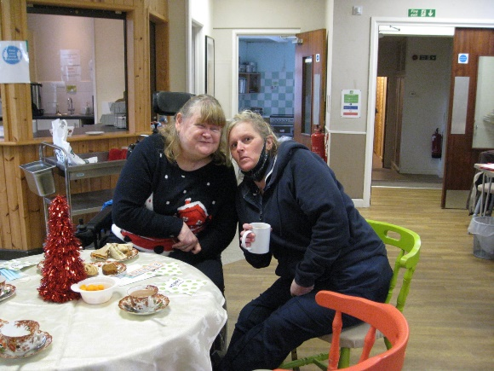
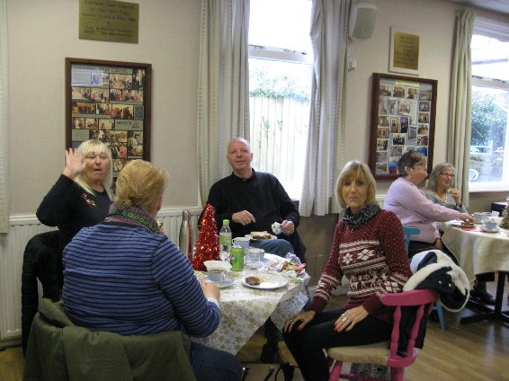

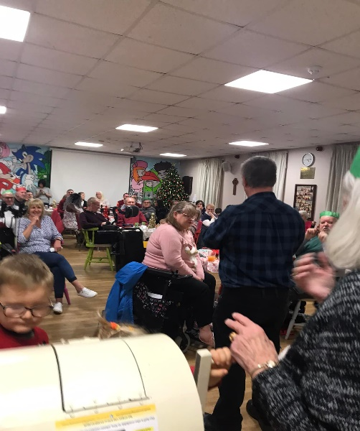

GREAT NEWS

BSL Bill passes 2nd reading: UK Deaf community celebrates important step towards legal status of British Sign Language
London, Friday 28 January 2022
Deaf people around the UK are celebrating a vital step towards the legal recognition of British Sign Language (BSL), after the BSL Bill passed its second reading in the House of Commons today.
BSL is the first language of 87,000 Deaf people in the UK. The language was formally recognised by the UK government in 2003 but still does not have full legal status, meaning many Deaf people are unable to access essential information and services in their first language.
Campaigners – including Strictly Come Dancing 2021 winner, Deaf actress Rose Ayling-Ellis – and charities supporting the BSL Act Now! campaign are celebrating the victory and calling upon MPs and ministers to get the Bill over the line.
The Bill still has to complete its passage through the House of Commons and the House of Lords. If passed, a BSL Act would increase both the official status and public awareness of BSL. Government Departments and public bodies would also be required to adhere to and report their performance against new guidance, setting out how they must meet the needs of BSL users.
The Bill was presented as a Private Member’s Bill by Labour MP Rosie Cooper, who is a Child of Deaf Adults (CODA) and considers BSL her first language. The Bill was passed unanimously.
Rosie has worked closely with Deaf sector organisations from the BSL Act Now! Campaign coalition, led by the British Deaf Association, including RNID, the Royal Association for Deaf People, SignHealth, National Deaf Children’s Society, Black Deaf UK, Signature, iBSL and the National Register of Communication Professionals working with Deaf and Deafblind People (NRCPD).
Speaking to The Big Issue this month, Rose Ayling-Ellis said that achieving legal recognition for BSL would be ‘emotional’, as ‘a lot of people don’t realise how much of a fight the deaf community have had’.
David Buxton, Chair of the British Deaf Association, said:
“This Bill has been nineteen years in the making. Deaf people in Britain never gave up hope that their language would one day be not only recognised in law, but also protected and promoted so that Deaf people are finally able to access information and services and achieve their potential on an equal basis with their fellow hearing citizens. I now call upon Ministers and MPs to do everything their can to get the British Sign Language Bill to Royal Assent in this parliamentary session.”
Mark Atkinson, Chief Executive of RNID, said:
“This is a momentous day for the Deaf community where we celebrate moving a massive step closer to full legal recognition for BSL. We are thrilled that the Bill has been approved in principle by MPs and will now move onto the next stages of the legislative process.
“The Bill includes important mechanisms which will provide government departments and public services with guidance explaining how they are required to meet the needs of BSL users. This will help ensure BSL users are fully included in society.
“We celebrate with the Deaf community today and we hope parliamentarians will now give Rosie Cooper all the support she needs to get this Bill passed into legislation and give BSL and deaf people the recognition they deserve.”
Lindsay Foster, Executive Director at Signature, said:
“Today is a great day for Deaf people across the UK as we move forward towards seeing BSL getting full legal recognition.
“We are proud to have played a part in the campaign, which today has made a huge step in the right direction to breaking down communication barriers for all, which the sector has pulled together to achieve.
“We look forward to continuing working with colleagues across the sector to get this through the final stages and this along with the continued positive developments towards GCSE in BSL will make a significant difference to so many people’s lives.”
Rosie Cooper MP, said:
“I am delighted that the Bill has passed this huge hurdle. Deaf people have been waiting for 230 years for the legal recognition of BSL, and that goal is now in sight.
“I am glad the Government have agreed to support this Bill, which I hope will allow it safe passage to be made into law.”
